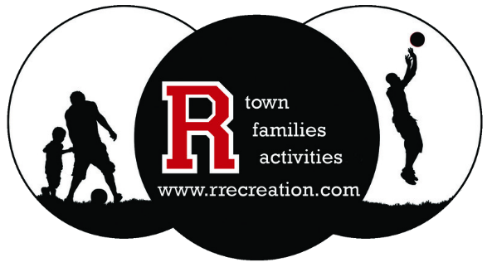
Register Online
www.rrecreation.com
Form of Payment (Circle)
Cash Check
Check # ________
Amount Paid: ________

| Registration Form |
Participant Name:_______________________________________________________________________________
Address: ________________________________________ City:____________________ State:_____ Zip:________
Date of Birth: ____________________ Grade: ______ Gender (Circle): Male or Female
Email Address: __________________________________________ Phone Number: _________________________
(Confirmation will be delivered via email only)
Parent/Guardian Name: ____________________________________ Phone Number: ________________________
(If participant is under 18, please provide us with a parent/guardian name and phone number)
Emergency Contact: ______________________________________ Phone Number:_________________________
(Only required if you are the participant and/or different from parent/guardian information)

Class Name | Dates | Days | Times | Location | Cost

Initial
Iniial
I,_________________ participant and/or parent/guardian, hereby give permission for CWC to use the likeness of myself and/or child for promotional purposes, such as newsletters, flyers, social media, brochures, etc.

Initial
I,__________________ participant and/or parent/guardian, hereby give permission for any and all medical attention to be administered to myself and/or child in the event of accident, injury, sickness, etc. under the direction of CWC/R Recreation. I also assume the responsibility for the payment of any such treatment. In consideration for the acceptance of myself and/or child’s entry, I hereby, for myself, my child, and my heirs, waive and release any and all rights and claims for damages I or my child may have against Central Wyoming College, R Recreation, School District 25, City of Riverton, Dist. 25 Recreation Board and their representatives and assigns for any and all injuries or damages suffered by myself or my child at any activity sponsored by Central Wyoming College/R Recreation.
I understand that during an activity, myself and/or child’s conduct directly affects the good order and safety of the group. I expect myself and/or child to exhibit conduct and behavior in accordance with institutional rules and program expectations. I agree that acts such as using tobacco, speaking with profanity, consuming intoxicating substances, fighting, bullying, inappropriate behavior, or theft will not be tolerated. I agree to be financially responsible for any loss, damage, or costs to persons or property caused by the actions of myself and/or child. If, at the sole discretion of the registered adult leader on an activity, myself and/or child’s behavior/conduct violates institutional regulations and program expectations, I understand that myself and/or my child’s opportunity to participate will be terminated and arrangements will need to be made to leave the program and facility at such time.

Participant Signature: _______________________________________________ Date: ________________________

